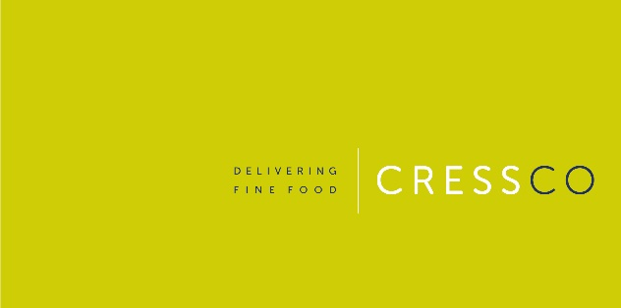

BRAND INTRODUCTION FORM

Supplier name and address:

Contact details:

|  |  |
| --- | --- |
| **Brand Story & Strategy** | Example…  **TrueStart makes delicious, healthy coffee that makes you feel amazing!**  Our mission is to make the world happier and healthier one cup at a time, bringing vibrancy and innovation to a coffee industry. We're proud to be a B Corp certified, Carbon Negative, family-run business that is dedicated to improving our society too.  Our journey began 8 years ago when our founders, Helena and Simon, discovered that caffeine levels in coffee vary enormously, leaving you feeling different every time you drink other coffees. Inspired by this revelation, they set out to craft a coffee that not only tastes amazing, but also makes you feel great, and consistently delivers the natural health benefits of coffee.  Hyper-selectively sourced, innovatively air-roasted and carefully tested, each cup of TrueStart contains more anti-oxidants than a cup of green tea and contains the perfect level of natural caffeine for a great feeling, without the crash or jitters.  Our signature Energising Colombian roast is the one that started it all, sourced from where Helena used to live in Colombia. High in the Andean mountains, TrueStart's beans are slowly grown, soaking up the richness of the volcanic soil in a unique microclimate.  An antidote to hipster nonsense, TrueStart is speciality grade coffee for everyone to enjoy, regardless of how you prefer to drink it. Our delicious range spans from Barista Grade Instant Coffee to Freshly Roasted Beans and even Cold Brew Cans.  Initially, TrueStart gained recognition as the Original Healthy Coffee, a brand with a unique and fascinating backstory that started with industry-leading innovation, as the world’s first coffee to have a regulated level of caffeine. We have fuelled all types of people, become ambassadors in the B Corp community and even opened a TrueStart Coffee shop. Now, TrueStart is one of the fastest-growing F&B brands in the UK.  In every cup of TrueStart Coffee, you'll find our commitment to happiness, health and massive positive energy. Our goal is to continue innovating, and making people feel their best self with TrueStart one delicious cup at a time. |
| **Current Route to Market** | Example…  Direct business, other distributors, online?  Direct to retail within Independent sector?  Listed with the multiples?  Listed with other distributors (please specify)? |
| **Current Marketing Activity and Proposed Marketing Support for Launch** | Example…  Support with catalogue and web advertising  Sample support  Trade show attendance  Promotional support |
| **Production capacity and lead time** | Example…  5 day lead time from order receipt to delivery  Description of production facility and capability |
| **Packaging is shelf ready** | Example…  Barcodes supplied on individual item as well as outer  BB Date supplied on individual item and outer  Outer packaging is robust and suitable for onward transportation |
| **Ambient/Chill Shelf life** | Example…  Shelf life on production  Shelf life on delivery to Cress  Ambient or Chill? |
| **Case size** | Example…  6 x 250g |
| **Price Structure** | Example…  Include Price list for wholesale/distribution  Include price list for retailers you are currently servicing direct  Include RRP on price list |

Pack image examples –

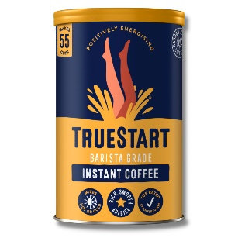

Outer case image example illustrating requirements –

